**Networking**

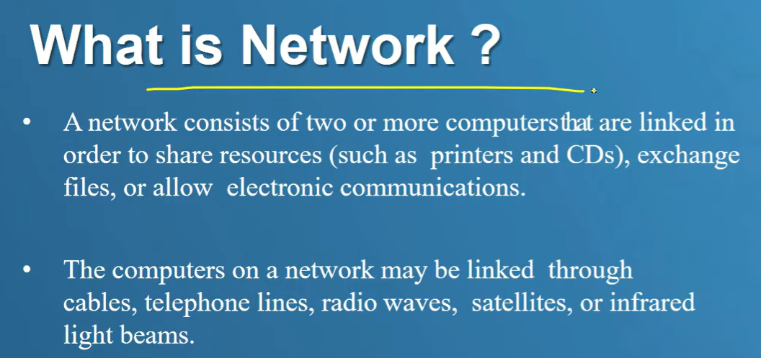

**INTERNET SERVICE PROVIDER**

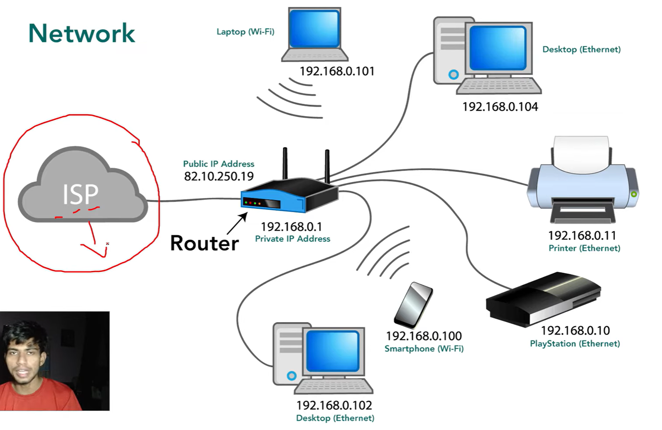 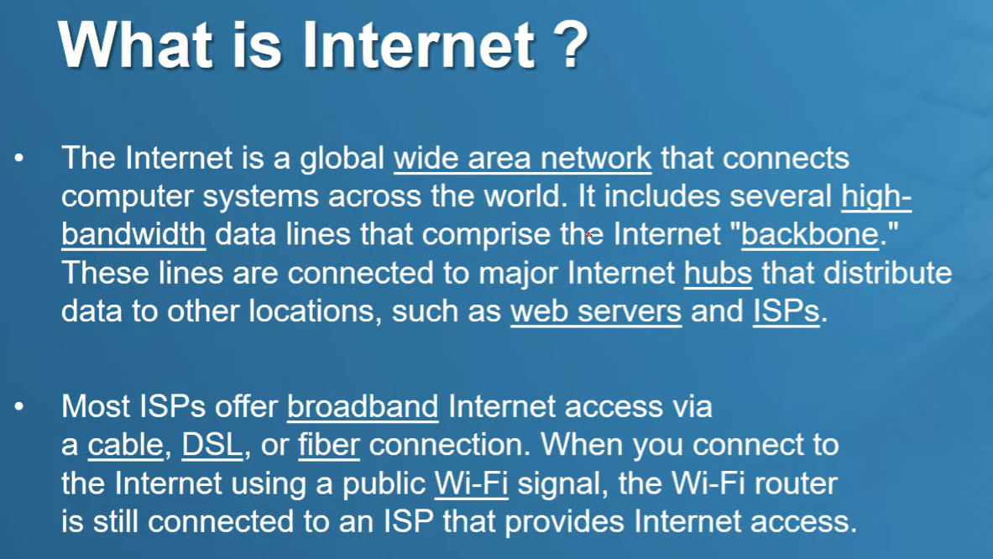

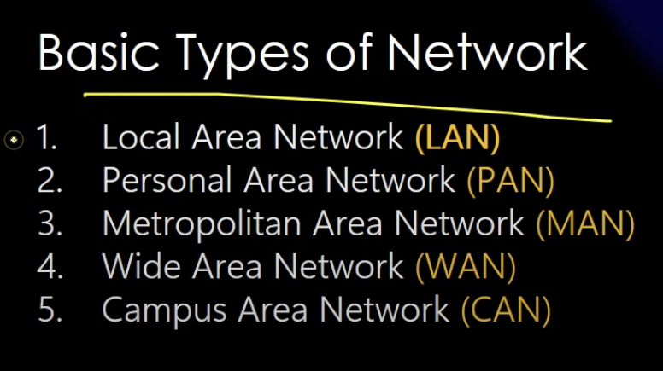

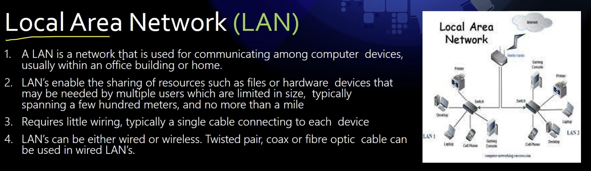

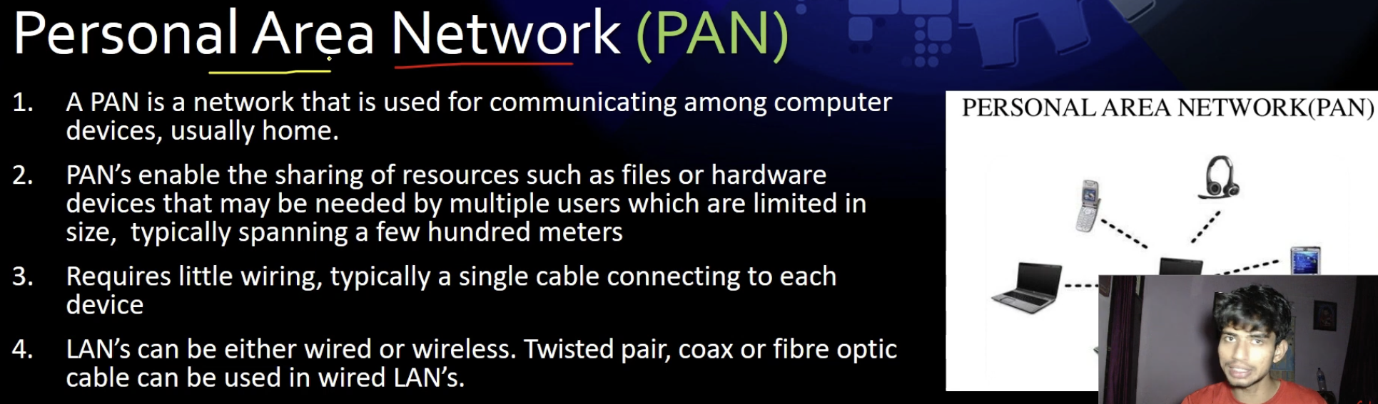

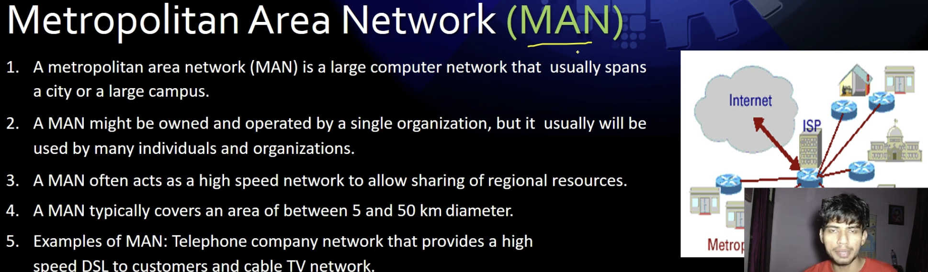

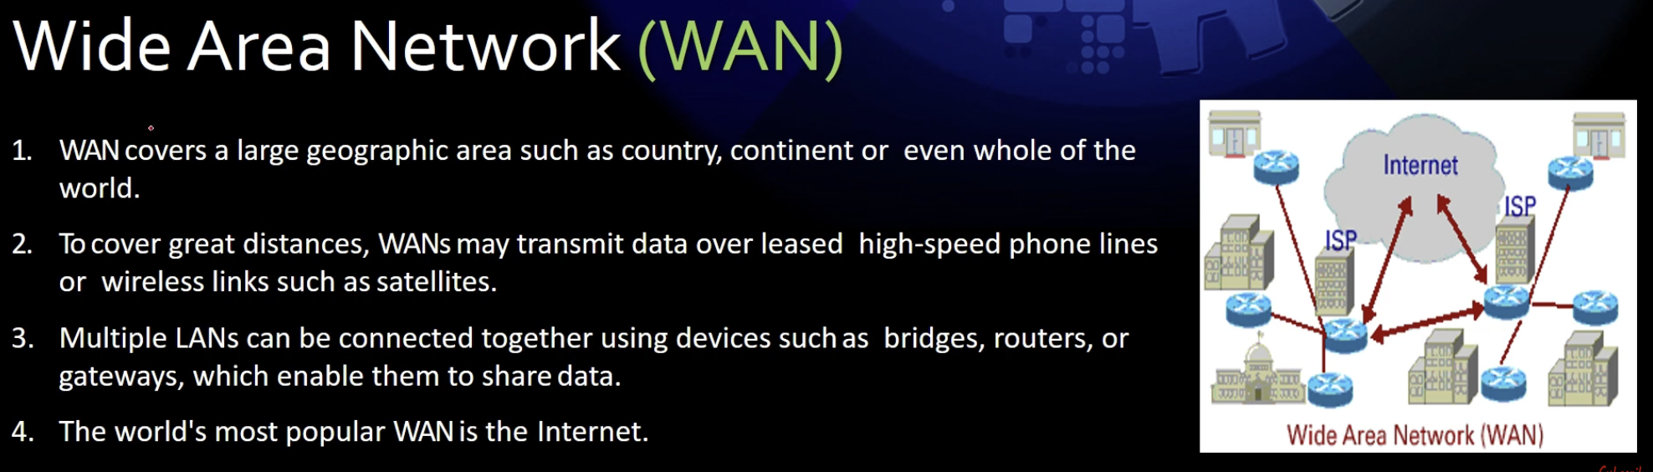

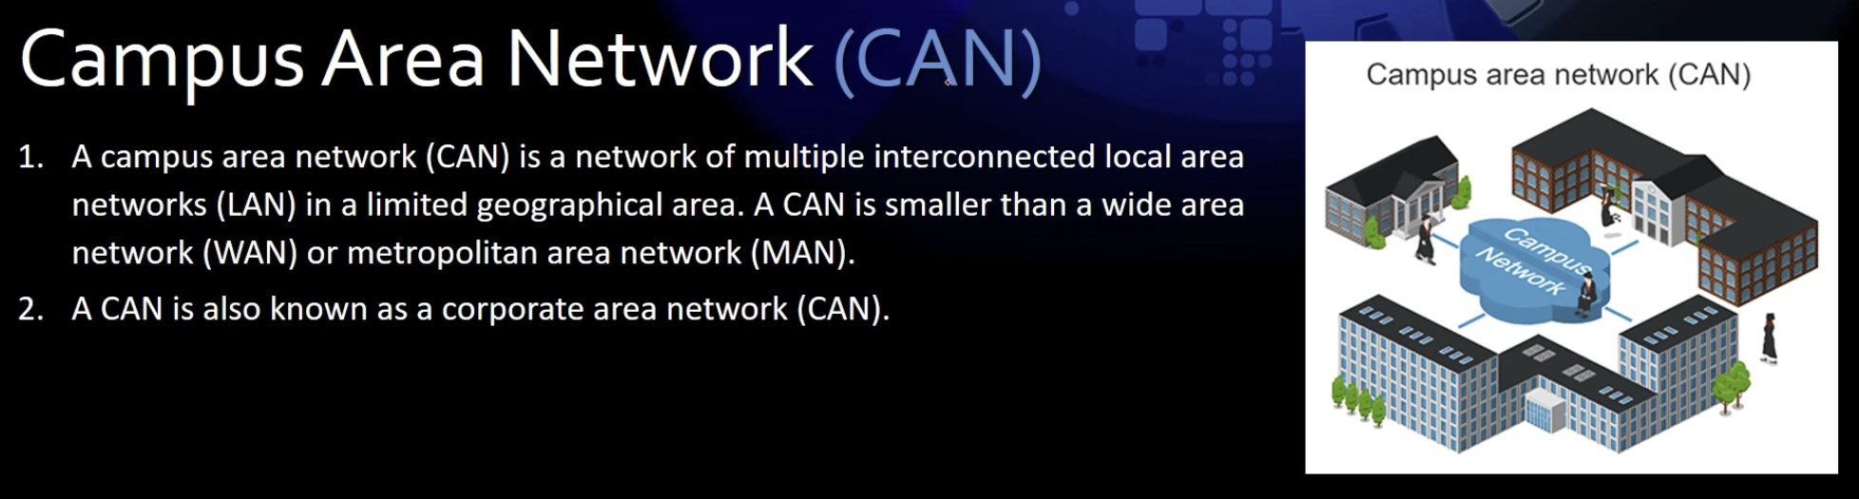

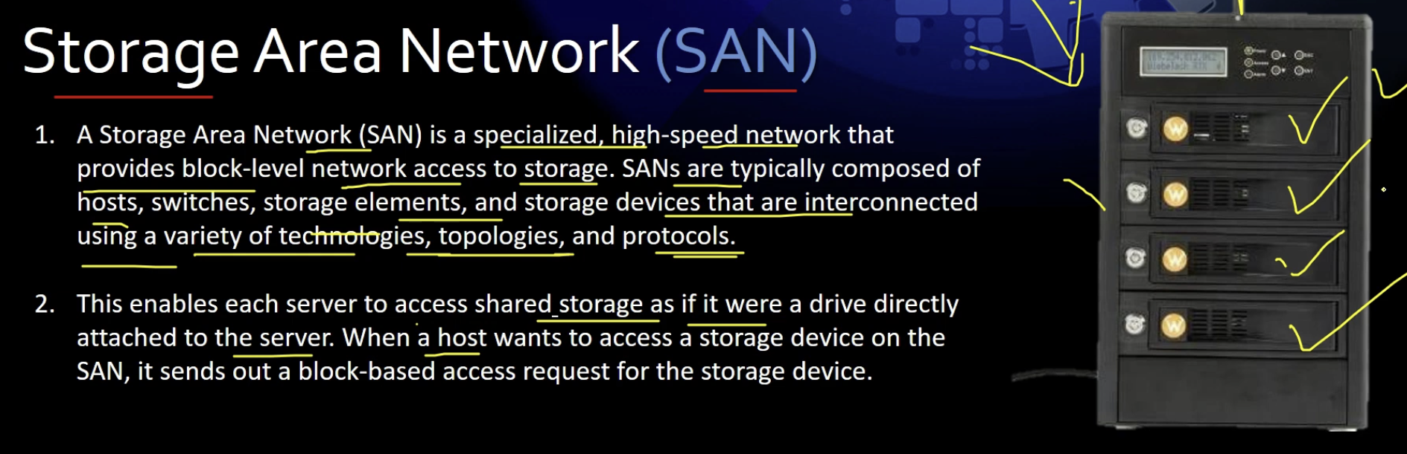

**When you type something in Google and hit search, the following steps occur:**

1. **DNS Resolution: Your browser first checks if it already knows the IP address of Google's servers. If not, it queries a DNS (Domain Name System) server to convert www.google.com into an IP address.**
2. **Network Routing:**
   * **Your request travels from your device (which has a private IP) to your router (which also has a private IP).**
   * **The router forwards the request to your ISP (Internet Service Provider), which assigns you a public IP.**
   * **The request then travels through multiple network hops, including ISPs, data centers, and undersea cables, until it reaches Google’s servers (often in the nearest data center, not necessarily the USA).**
3. **Processing at Google's Server:**
   * **Google's servers process your query using their search algorithms.**
   * **The results are retrieved from their massive database.**
4. **Response Transmission:**
   * **The response data follows the reverse path, traveling back through ISPs, routers, and finally reaching your device.**
5. **Rendering the Results:**
   * **Your browser receives the response and displays the search results.**

**Check the Network Path**

**To see how your request travels, you can open CMD (Command Prompt) and use:**

* **tracert google.com → Shows the path your request takes to reach Google’s servers.**
* **nslookup google.com → Resolves Google's domain to an IP address.**

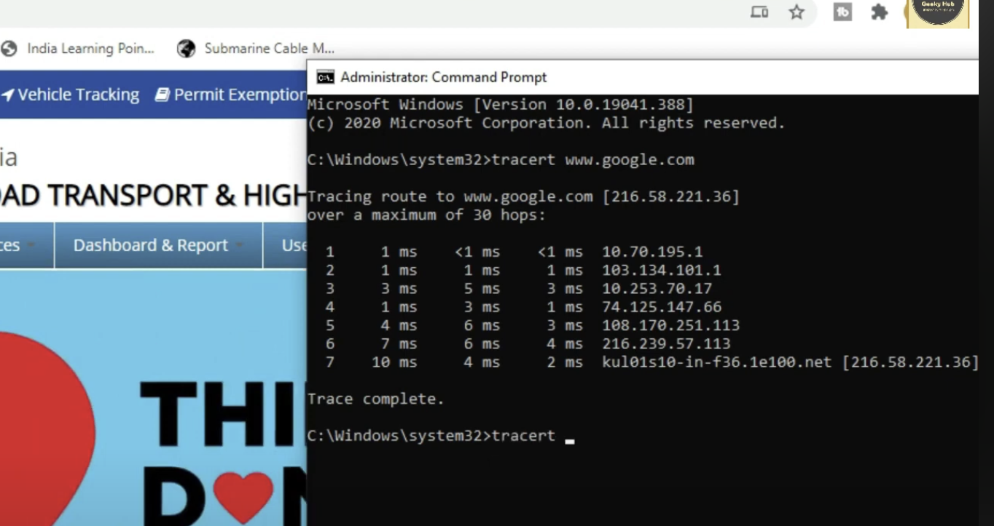

**Government officially will keep their server in india because of security.**

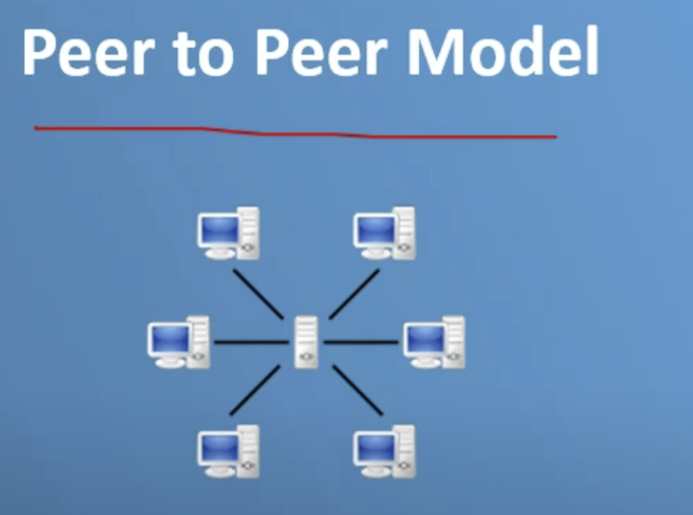

**It is independent model and there is no restrictions.**

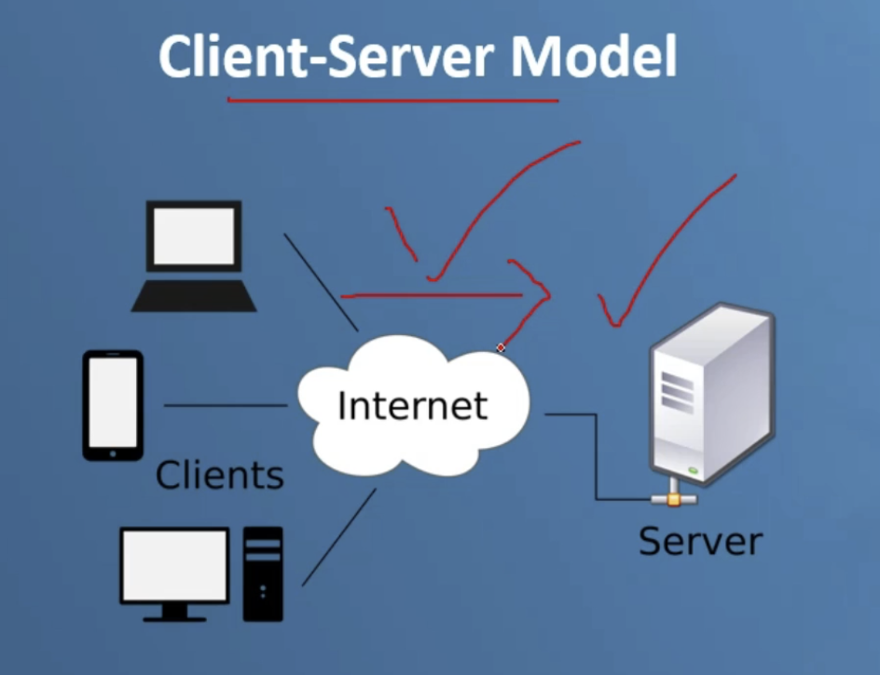

**This is dependent model where administrator has control.**

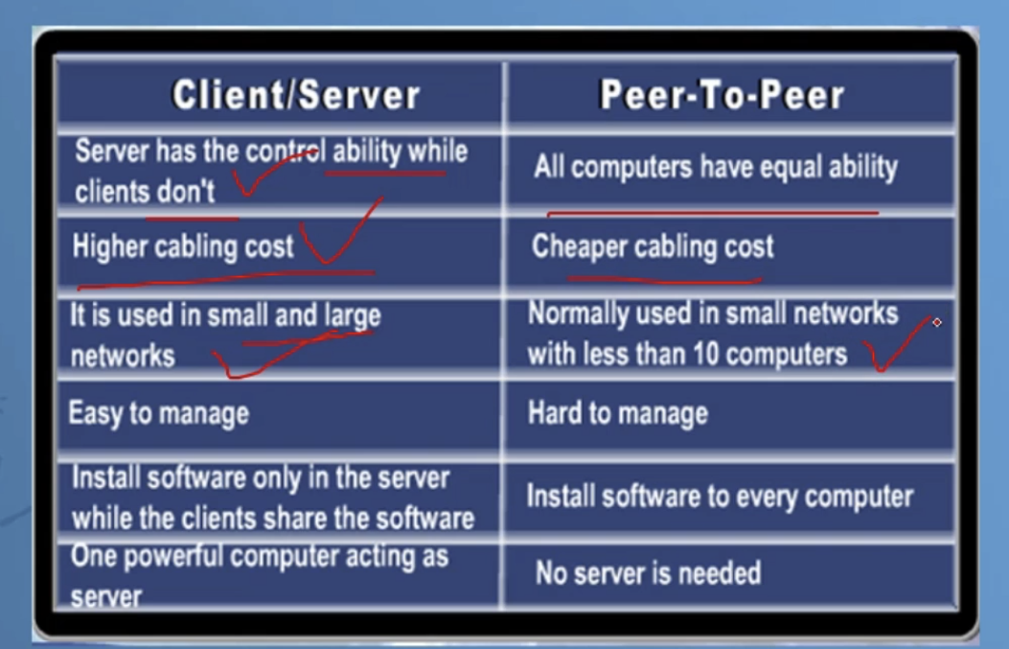

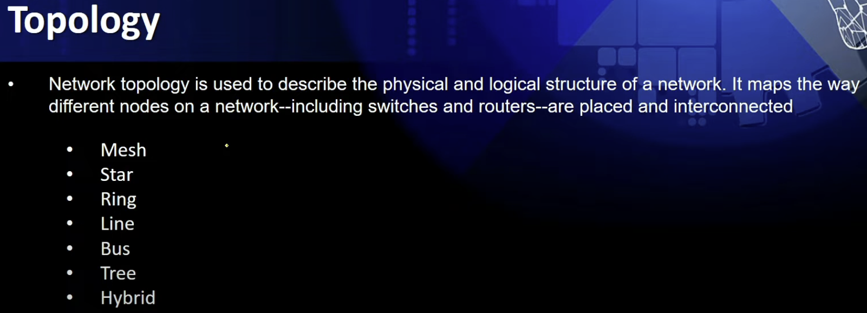

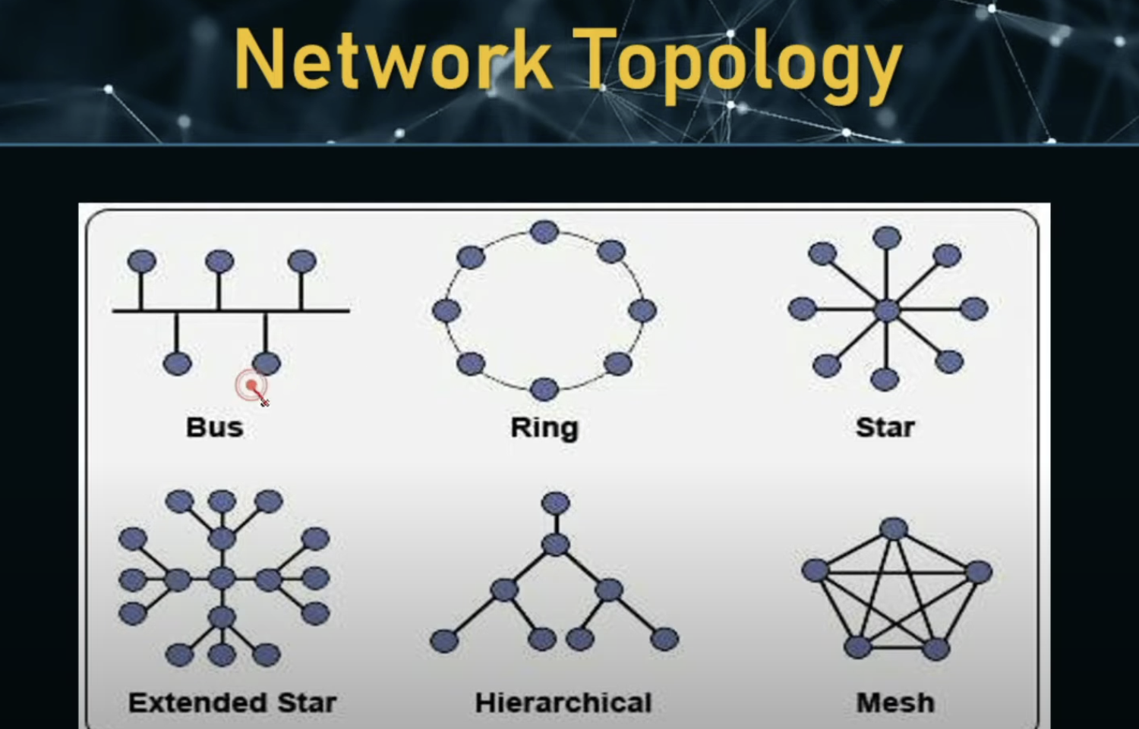

**Previously there was ip address but know iCANN how does this redirect to some domain**

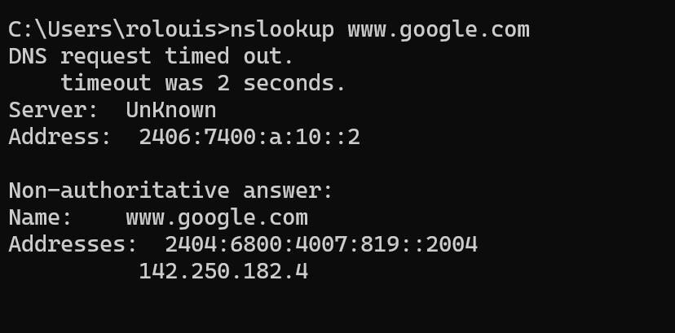

**What is a MAC Address?**

**A MAC (Media Access Control) address is a unique identifier assigned to a network interface card (NIC) of a device. It is used for communication within a local network (LAN) and operates at the Data Link Layer (Layer 2) of the OSI model.**

**Example of a MAC Address:**

**A MAC address is a 12-digit hexadecimal number (48 bits) typically written in one of the following formats:**

* **Colon-separated: 00:1A:2B:3C:4D:5E**
* **Dash-separated: 00-1A-2B-3C-4D-5E**
* **Without separators: 001A2B3C4D5E**

**Brief Meaning & Uses of MAC Address**

1. **Uniqueness: Every device has a unique MAC address, assigned by the manufacturer.**
2. **Device Identification: Helps in identifying devices within a local network.**
3. **Data Transmission: Used in Ethernet and Wi-Fi networks for device-to-device communication.**
4. **Network Security: MAC filtering can restrict access to specific devices.**
5. **Address Resolution Protocol (ARP): Helps map MAC addresses to IP addresses.**

**It will be 8bit**

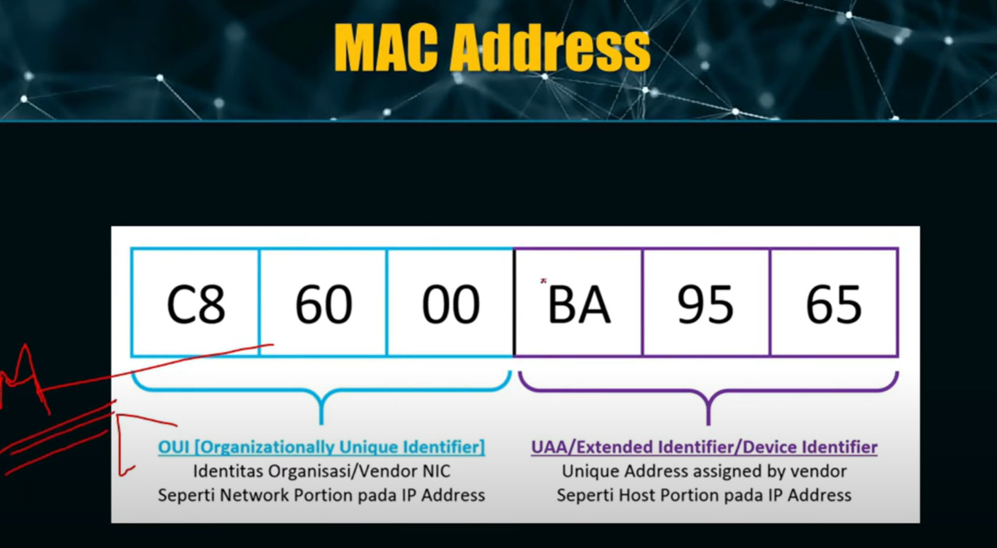

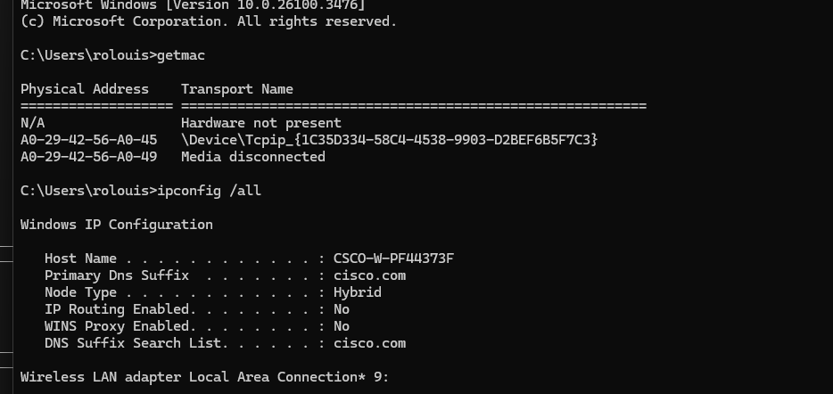

**1. TCP (Transmission Control Protocol)**

**Explanation:**

* **TCP is a connection-oriented protocol.**
* **It ensures reliable and ordered delivery of data.**
* **Uses error-checking and retransmission if data is lost.**
* **Slower than UDP due to extra overhead.**

**Example of TCP Usage:**

* **Web Browsing (HTTP/HTTPS) → When you visit a website, TCP ensures the complete webpage is delivered correctly.**
* **Email (SMTP, IMAP, POP3) → Emails require reliability, so TCP is used.**
* **File Transfers (FTP, SFTP) → Large files need error-checking to avoid corruption.**

**TCP Process Example:**

1. **Connection Establishment (Three-way handshake: SYN → SYN-ACK → ACK)**
2. **Data Transmission (Ensures all packets are received in order)**
3. **Connection Termination (FIN → ACK → FIN → ACK)**

**2. UDP (User Datagram Protocol)**

**Explanation:**

* **UDP is a connectionless protocol.**
* **It does not guarantee data delivery or order.**
* **No retransmissions, making it faster than TCP.**
* **Used when speed is more important than reliability.**

**Example of UDP Usage:**

* **Live Streaming (YouTube, Twitch, Netflix, VoIP) → Small delays are acceptable, but speed is crucial.**
* **Online Gaming → UDP ensures low latency by sending data without waiting for acknowledgments.**
* **DNS Queries → Domain Name System (DNS) requests are short and need to be fast.**

**UDP Process Example:**

1. **Data is sent directly without connection setup.**
2. **Packets may arrive in any order or be lost.**
3. **The receiver handles missing data if necessary.**

**Key Differences Between TCP and UDP**

| **Feature** | **TCP** | **UDP** |
| --- | --- | --- |
| **Type** | **Connection-Oriented** | **Connectionless** |
| **Reliability** | **High (Error-checking, Retransmission)** | **Low (No guarantees)** |
| **Speed** | **Slower (due to overhead)** | **Faster** |
| **Usage** | **Web browsing, email, file transfer** | **Streaming, gaming, VoIP, DNS** |

**Conclusion:**

* **Use TCP when reliability is important.**
* **Use UDP when speed is more important than perfect accuracy.**

**Let me know if you need more details! 🚀**

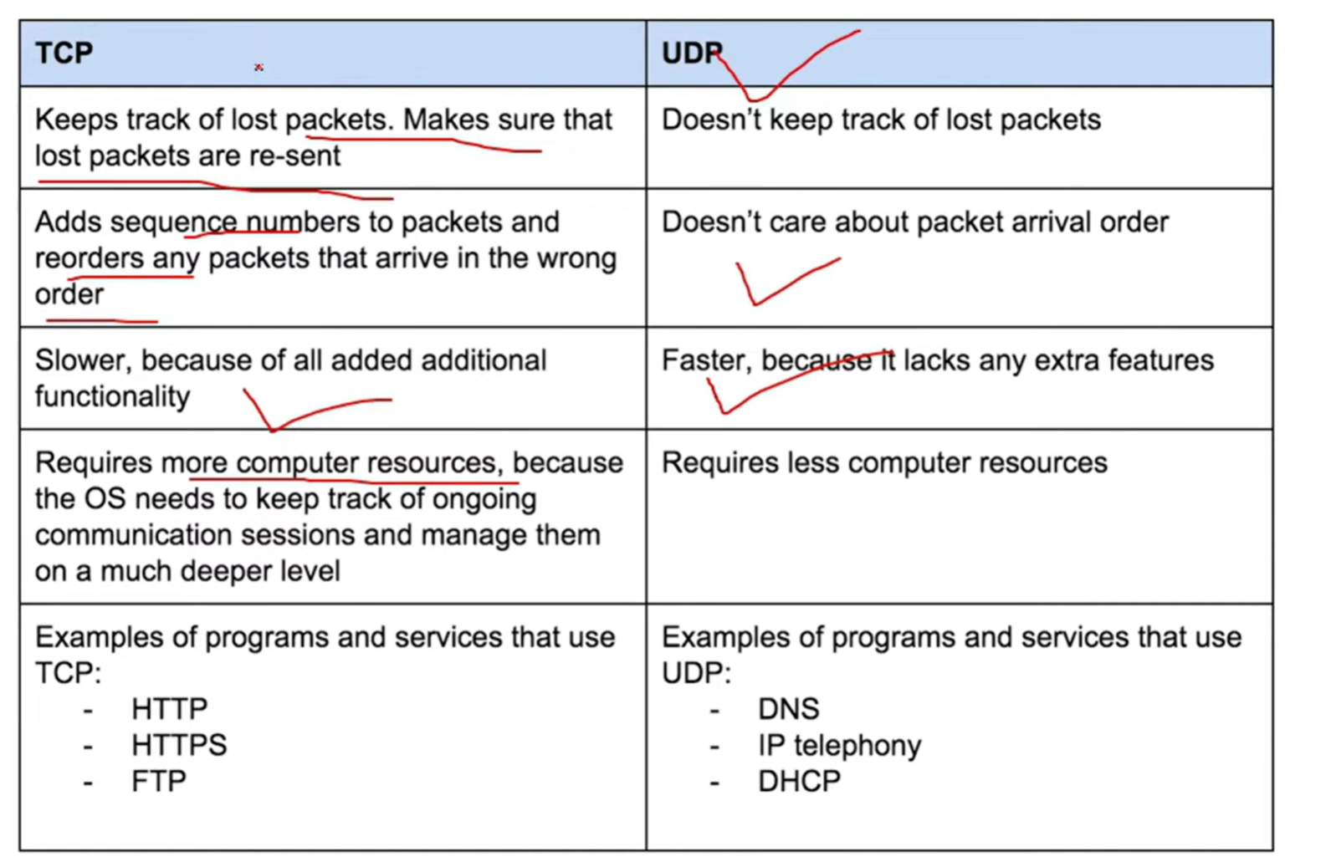

**MTP (Simple Mail Transfer Protocol)**

**What is SMTP?**

**SMTP (Simple Mail Transfer Protocol) is a communication protocol used for sending emails over the internet. It works at the Application Layer of the OSI model and uses TCP (Transmission Control Protocol) for reliable delivery.**

**How SMTP Works?**

**SMTP follows a client-server model, where an email client (e.g., Outlook, Gmail) sends an email to an SMTP server, which then forwards it to the recipient’s mail server.**

**SMTP Process:**

1. **User sends an email → The email client connects to the SMTP server.**
2. **SMTP server processes the email → It checks the recipient's domain.**
3. **Email forwarding → If the recipient’s email is on another server, SMTP forwards it.**
4. **Recipient's server receives the email → The email is stored and later retrieved using IMAP or POP3.**

**Example of SMTP Usage:**

* **Sending an email from Gmail to Yahoo Mail.**
* **Automated email notifications.**
* **Email services for business applications.**

**SMTP Ports**

| **Port** | **Usage** |
| --- | --- |
| **25** | **Default SMTP port (often blocked by ISPs to prevent spam).** |
| **465** | **SMTP with SSL encryption (deprecated but still in use).** |
| **587** | **Recommended SMTP port with STARTTLS encryption.** |
| **2525** | **Alternative SMTP port used when others are blocked.** |

**IP Address (Internet Protocol Address)**

**What is an IP Address?**

**An IP address is a unique numerical identifier assigned to each device connected to a network. It allows devices to communicate with each other over the internet or a local network.**

**Types of IP Addresses**

**1. IPv4 (Internet Protocol Version 4)**

* **32-bit address (e.g., 192.168.1.1)**
* **Contains four decimal numbers separated by dots.**
* **Limited to 4.3 billion unique addresses.**

**2. IPv6 (Internet Protocol Version 6)**

* **128-bit address (e.g., 2001:0db8:85a3:0000:0000:8a2e:0370:7334)**
* **Uses hexadecimal notation with colons.**
* **Provides an almost unlimited number of addresses.**

**Categories of IP Addresses**

**1. Private IP Address (Used Inside a Network)**

* **Assigned to devices within a private network (e.g., home, office).**
* **Cannot be used on the internet.**
* **Examples:**
  + **192.168.0.1 (Most home routers)**
  + **10.0.0.1 (Used in corporate networks)**

**2. Public IP Address (Used on the Internet)**

* **Assigned by Internet Service Providers (ISPs).**
* **Used to communicate over the internet.**
* **Example: 203.0.113.5**

**Static vs Dynamic IP Addresses**

| **Type** | **Description** | **Example** |
| --- | --- | --- |
| **Static IP** | **Manually assigned, doesn’t change** | **Used for servers, websites** |
| **Dynamic IP** | **Assigned by DHCP, changes over time** | **Used for home users** |

**Uses of an IP Address**

1. **Device Identification → Every device gets a unique IP.**
2. **Internet Communication → Required for sending/receiving data.**
3. **Hosting Websites → Websites need an IP to be accessible.**
4. **Geolocation Tracking → Approximate location can be identified.**

**Example of an IP Communication Process**

1. **You type www.google.com in your browser.**
2. **Your device contacts a DNS server to get Google’s IP.**
3. **Your device sends a request to Google’s public IP address.**
4. **Google’s server responds, and you see the webpage.**

**Subnet Mask: Definition & Explanation**

**A Subnet Mask is a 32-bit number used to divide an IP address into network and host portions. It helps determine which part of an IP address belongs to the network and which part identifies a specific device (host) in that network.**

**Example of an IP Address & Subnet Mask**

**Let’s take an IP address and a subnet mask:**

**nginx**

**CopyEdit**

**IP Address: 192.168.1.10**

**Subnet Mask: 255.255.255.0**

* **Network portion: 192.168.1**
* **Host portion: 10 (Device ID in the network)**

**In this case, all devices in the 192.168.1.x range belong to the same network.**

**Common Subnet Masks & Their Uses**

| **Subnet Mask** | **CIDR Notation** | **Network Size** | **Usable Hosts** |
| --- | --- | --- | --- |
| **255.0.0.0** | **/8** | **Large Networks** | **16,777,214 hosts** |
| **255.255.0.0** | **/16** | **Medium Networks** | **65,534 hosts** |
| **255.255.255.0** | **/24** | **Small Networks** | **254 hosts** |
| **255.255.255.128** | **/25** | **Very Small Network** | **126 hosts** |

**Why is a Subnet Mask Important?**

1. **Efficient IP Addressing → Helps split large networks into smaller ones.**
2. **Network Security → Prevents unnecessary communication between unrelated networks.**
3. **Traffic Management → Reduces congestion by segmenting network traffic.**
4. **Routing Decisions → Routers use subnet masks to determine if a destination is local or remote.**

**Subnet Mask Calculation Example**

**Suppose you have 192.168.1.10/24 (255.255.255.0).**

* **Network Address: 192.168.1.0**
* **Broadcast Address: 192.168.1.255**
* **Usable IPs: 192.168.1.1 to 192.168.1.254**

**Conclusion**

**A subnet mask helps in identifying network and host parts of an IP address, enabling efficient network design and management.**

**Let me know if you need subnetting examples! 🚀**

**DNS (Domain Name System) – Explained**

**What is DNS?**

**DNS (Domain Name System) is a system that translates human-friendly domain names (like www.google.com) into IP addresses (like 142.250.190.46). It acts like the phonebook of the internet, allowing users to access websites without memorizing numerical IP addresses.**

**How DNS Works?**

**When you type a URL (www.google.com) into your browser:**

1. **DNS Query Starts → Your device asks a DNS server for the IP address of www.google.com.**
2. **DNS Lookup Process → The DNS system checks if the IP is cached or needs to be found.**
3. **DNS Resolves the IP → The correct IP address (142.250.190.46) is returned.**
4. **Website Loads → Your browser connects to the website's server using the IP.**

**Types of DNS Servers**

1. **Recursive Resolver → Your ISP’s DNS server that looks up the domain.**
2. **Root DNS Server → The first step in resolving a domain name (.).**
3. **TLD (Top-Level Domain) Server → Handles .com, .org, .net, etc.**
4. **Authoritative Name Server → Stores actual domain-to-IP mapping.**

**Uses of DNS**

**✅ Simplifies browsing → Users don’t need to remember IPs.  
✅ Load balancing → Directs traffic to different servers.  
✅ Email routing → Helps in email delivery with MX records.  
✅ Security → DNS filtering can block malicious sites.**

**Conclusion**

**DNS is essential for the internet, acting as a translator between human-readable domain names and machine-friendly IP addresses.**